We Can Do It

Growing up should be a happy time in a girl’s life. What can make their lives a misery during this time then? In my opinion, there is one word which answers this question - confinement.

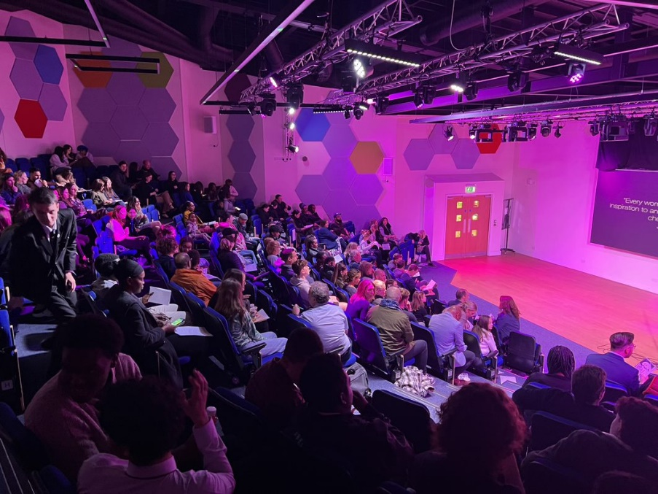
It’s not uncommon to see girls and women being repressed from sports and job opportunities solely because of their sex. It can affect females of any age. Girls as young as twelve or thirteen are constantly subject to the dull litany of being told what they can and can’t do. “You can’t do football — try ballet.” “You can’t cut your hair short — boys don’t like that.” Unfortunately, this is only the beginning of something more serious. Around different parts of the world, women are denied access to their rights — one being their right to work. Since the devastating takeover of Afghanistan by the Taliban in the August of 2021, women have been excluded from public offices. This means that they must unwillingly put all their dependence on men whether that be their husbands, brothers or fathers. From their youth, Afghan girls are socialised to accept that they are second class to the men around them — they must be married off at a young age, settle and have children, while their brother’s only goal is to be successful.

It may not affect us all, but it’s important to highlight what standards are being set in society. Women must be dependent on men and are looked down upon, or even shunned in some cultures, when they seek independence. I have found that there is a recurring theme in history that shows women are essentially nothing if not for a man. Take Henry VIII and his wives — how many of us know their names? Or what they did? What they accomplished in society? Why is it that women only have a sliver importance when it’s in relation to a man?

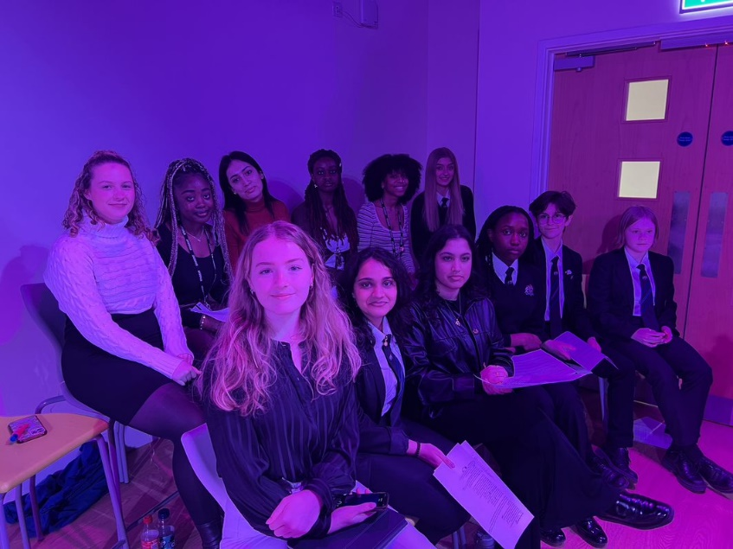
Women can exist without men and the “We Can Do It” campaign underlined this for all to heed. The “We Can do It” movement comprised of speeches written by empowered women that refuse to let boxes confine them and these are messages that all growing girls need to hear. It was a safe space for awareness to be spread in hopes of not only girls to be inspired but boys and men too. For youth in the audience, they were told that they aren’t the only ones struggling with beauty standards, hair or skin colour. On that night, it was made known that women can do predominantly ‘male’ sports. Women can be beautiful through harsh beauty standards. Throughout history, women have faced major setbacks, despite this, this difficulty has been combatted in several ways. Women will find a way to find justice and live within our rights.

